**SYNOPSIS**

**Report on**

**“ONLINE SALES MONITORING SYSTEM”**

**By**

**MEGHA CHAUDHARY**

**Session: 2023-2024 (IV Semester)**

**Under the supervision of**

**Dr. AMIT KUMAR(Asst. Professor)**

### KIET Group of Institutions, Delhi-NCR, Ghaziabad



### Department Of Computer Applications

**KIET GROUP OF INSTITUTIONS, DELHI-NCR, GHAZIABAD-201206**

(2023- 2024)

**ABSTRACT**

The Online Sales Monitoring System is a critical tool for businesses aiming to enhance their sales performance and streamline operations. This system provides real-time insights into sales activities, allowing organizations to make informed decisions and optimize their sales processes.

the Online Sales Monitoring System empowers businesses to make data-driven decisions, optimize sales processes, and achieve better sales performance.

The Sales Monitoring System is a powerful tool designed to enhance sales performance, provide real-time insights, and streamline sales operations. By monitoring and facilitating sales activities, this system empowers organizations to make informed decisions and optimize their sales processes effectively.

**TABLE OF CONTENTS**

Page Number

1. Introduction --
2. Problem Statement --
3. Project Objective --
4. Project Outcome --
5. System Description/Modules --
6. System Requirement --
7. DFD --

References --

**INTRODUCTION**

The Sales Monitoring System is a powerful tool designed to enhance sales performance, provide real-time insights, and streamline sales operations. By monitoring and facilitating sales activities, this system empowers organizations to make informed decisions and optimize their sales processes effectively. At this time information development has developed very rapidly, therefore many companies have used information systems to improve their businesses. To improve a company's business is by building a good information system, and the requirement to build a good information system that is the speed and accuracy to obtain the information needed. A computer is a tool that can store data, process data, and provide desired information accurately and accurately that is useful for the company to progress its business. In the process of development, a company needs a monitoring system for good sales so that the information data obtained can be maximized or even lost/difficult to find if the data is needed by the parties needed to make a decision. If the sales Monitoring system cannot be managed properly, it will cause various kinds of problems that can disrupt the activities or activities of the company. Therefore, it is very important for the company to maintain these systems

**BACKGROUND/PROBLEM STATEMENT**

In today’s dynamic business environment, effective sales management is critical for organizational success. However, traditional manual methods for tracking sales activities are often inefficient and error-prone. Businesses face challenges such as:

1. **Lack of Real-Time Insights**:

Manual tracking hinders real-time visibility into sales performance.

Decision-makers struggle to assess revenue expectations and identify growth opportunities promptly.

1. **Inconsistent Processes**:

Without standardized processes, critical details may be overlooked.

Sales teams need a systematic approach to manage leads and monitor progress.

1. **Resource Intensiveness**:

Manual data entry and repetitive tasks consume valuable time and resources.

Sales reps spend less time on revenue-generating activities.

The **Sales Monitoring System** aims to address these challenges by providing a centralized dashboard for sales operations. It offers real-time insights, lead tracking, and data-driven decision-making. By automating processes and enhancing visibility, this system empowers businesses to optimize their sales strategies effectively.

**PROJECT OBJECTIVE**

The project objective for the Sales Monitoring System is to create a robust and efficient solution that addresses the following key goals:

1. **Real-Time Insights and Monitoring:**

Provide a centralized dashboard that offers real-time visibility into sales operations.

Enable sales managers and teams to track performance metrics, monitor leads, and assess revenue expectations.

1. **Lead Tracking and Engagement:**

Develop a system that tracks leads as they progress through the sales funnel.

Remind sales representatives of follow-ups and content delivery based on the prospect’s buying stage.

1. **Data-Driven Decision-Making:**

Collect engagement data, including interactions with prospects.

Provide actionable insights to improve sales strategies and optimize processes.

The Sales Monitoring System aims to empower businesses with accurate information, streamline sales activities, and enhance overall sales performance

**PROJECT OUTCOME**

the objectives for a **Sales Monitoring System**, it’s essential to align them with the overall goals of your organization. Here are some key objectives that a robust sales monitoring system should aim to achieve:

1. **Target Monitoring**:
   * A well-designed sales force monitoring system should provide an **interactive dashboard** displaying metrics such as:
     + The number of tasks completed by each salesperson.
     + Customer visits and details about those visits.
     + Inventory management by sales reps.
2. **Tracking Task Completion**:
   * The system should rigorously track task schedules and monitor location data through **GPS.**
3. **Strategy Communication**:
   * Effective communication is vital. The system should:
     + Notify salespeople of the day’s plan.
     + Allow managers to modify plans centrally.
4. **Customer Segmentation**:
   * Understanding customer buying patterns is essential.
5. **Performance Reporting**:
   * Summarize sales operations and performance parameters into **easy-to-understand reports.**
6. **Lead Tracking and Engagement**:
   * The system should track leads throughout the sales funnel.
   * Remind sales reps to follow up based on prospect buying stages.

**SYSTEM DESCRIPTION**

This system plays a pivotal role in optimizing sales processes, enhancing efficiency, and ensuring effective management. Here are the key components of such a system:

1. **Data Collection and Integration**:
   * The system aggregates data from various sources:
     + **Sales Transactions**: Captures details of sales orders, invoices, and customer interactions.
     + **Inventory Management**: Tracks stock levels, replenishment, and movement.
     + **Customer Information**: Stores customer profiles, preferences, and purchase history.
   * Integration with other systems (e.g., CRM, ERP) ensures seamless data flow.
2. **Real-Time Monitoring and Alerts**:
   * The system continuously monitors sales activities:
     + **Sales Rep Movements**: Utilizes GPS tracking to monitor field sales reps’ locations.
     + **Order Fulfillment**: Alerts managers if orders are delayed or not processed.
     + **Inventory Levels**: Notifies when stock reaches critical levels.
   * Real-time alerts enable swift corrective actions.
3. **Dashboard and Reporting**:
   * An intuitive dashboard provides visual insights:
4. **Sales Performance Metrics**: Displays sales revenue, targets, and growth trends.
   * + **Geographical Analysis**: Maps sales territories and hotspots.
     + **Product Performance**: Highlights top-selling products.
   * Customizable reports aid decision-making.
5. **Salesperson Performance Evaluation**:
   * The system assesses individual sales reps:
     + **KPI Tracking**: Measures key performance indicators (e.g., conversion rate, average deal size).
     + **Task Completion**: Monitors adherence to schedules and tasks.
     + **Lead Conversion**: Evaluates lead-to-customer conversion rates.
   * Performance data informs training and incentives.
6. **Customer Relationship Management (CRM)**:
   * Integrating CRM functionalities streamlines sales processes:
     + **Lead Management**: Tracks leads from initial contact to conversion.
     + **Customer Segmentation**: Categorizes clients for targeted marketing.
     + **Follow-Up Reminders**: Ensures timely communication.
   * A robust CRM enhances customer satisfaction.
7. **Security and Access Control**:
   * The system safeguards sensitive data:
     + **User Authentication**: Ensures authorized access.
     + **Data Encryption**: Protects customer information.
     + **Role-Based Permissions**: Controls who can view/edit data.
   * Compliance with data privacy regulations is crucial.
8. **Scalability and Flexibility**:
   * The system should accommodate growth:
     + **Multi-Channel Support**: Handles online, offline, and mobile sales.
     + **Customization**: Adapts to changing business needs.
     + **Integration with Third-Party Tools**: Facilitates scalability.

**DATA FLOW DIAGRAM (DFD)**

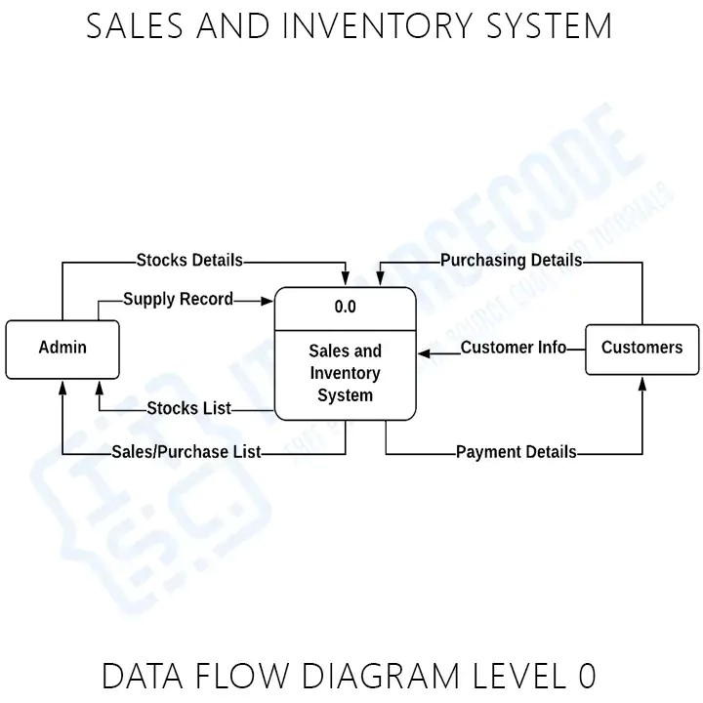

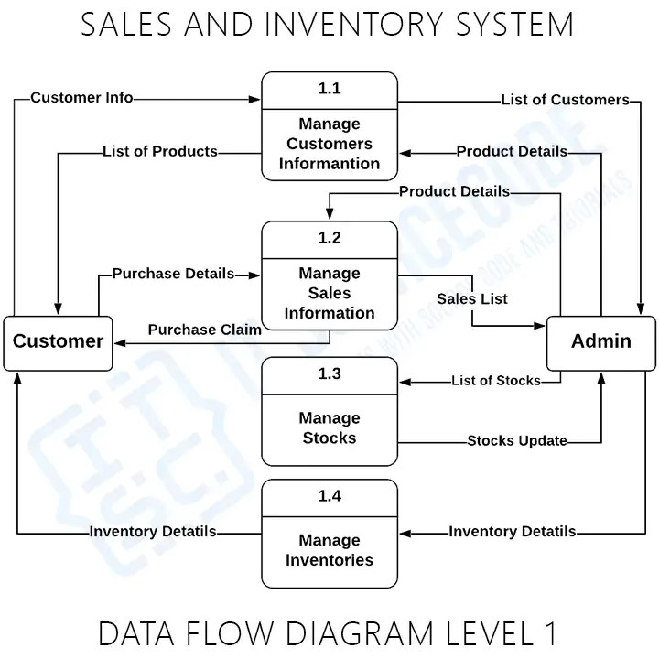

**Reference**

1. [***Use a Sales Monitoring System for Better Performance | LeadSquared***](https://www.leadsquared.com/learn/sales/sales-monitoring-system/)***:***
   * ***This article discusses the value of a sales monitoring system in improving sales performance.***[***It covers topics such as repeatable processes, streamlined operations, and remote selling capabilities1***](https://www.leadsquared.com/learn/sales/sales-monitoring-system/)***.***
2. [***Sales Monitoring: From Basics to Best Practices***](https://www.luru.app/post/sales-monitoring)***:***
   * [***Provides insights into sales monitoring, including data collection, metrics, and best practices2***](https://www.luru.app/post/sales-monitoring)***.***
3. [***Chapter 2 - Sales Monitoring System - studylib.net***](https://studylib.net/doc/9893635/chapter-2---sales-monitoring-system)***:***
   * [***Explores the role of sales and inventory data in decision-making within the supply chain***](https://www.leadsquared.com/learn/sales/sales-monitoring-system/)[***3***](https://studylib.net/doc/9893635/chapter-2---sales-monitoring-system)***.***
4. [***Sales Monitoring Systems: 4 Ways to Monitor Sales Team Performance - SPOTIO***](https://spotio.com/blog/sales-monitoring/)